CIRRCULLAM VITAE
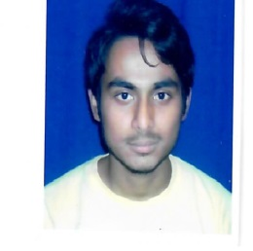

Rahul Biswas.
Santi Nagar (West).
Ananda Nagar.
Nischinda, Howrah- 711227.
Contact No. 9038371110, 9339356303.
Email id- biswasrahul9038@gmail.com

Objective:
To work in an organization that would provide the best opportunities for Personal and Professional growth.

Educational Qualification:
Examination | Board/ University | Year of Passing | Percentage
Madhyamik | W.B.B.S.E. | 2011 | 62%
H.S. | W.B.C.H.S.E. | 2013 | 63%
B.Com | C.U. | 2017 | 42%

Professional Qualification:
Knowledge on Basic, F.A., Tally ERP 9 & SAP(appeared) from Moulali Youth Computer Centre.

Work Experience
Generation Next BPO Service ( Loan Department)

Personal Details:
Father’s Name : Gouranga Biswas.
Date of Birth : 18/06/1994.
Languages Known : Bengali, Hindi, English.
Marital Status : Single.
Hobbies : Playing outdoor game, Reading story book, Listening to music.

DATE: SIGNATURE
PLACE:

